**Please complete this Testcase by using POM without PageFactory & TestNG:**

**SEARCH ITEMS :**

**LOCATORS:**

**package** pom.without.pagefactory;

**import** org.openqa.selenium.By;

**public** **class** Search_item {

**public** **static** By *SearchIndex* = By.*id*("inputValEnter");

//public static By password = By.id("password");

}

**EXCECUTION**

package pom.without.pagefactory;

import org.openqa.selenium.Keys;

import org.openqa.selenium.WebElement;

import com.test.Baseclass;

public class Search_page extends Baseclass {

public static Search_item item = new Search_item();

public static void SearchMethod() {

browserOpen("chrome");

loadUrl("https://www.snapdeal.com/")

WebElement ele = findElement(item.SearchIndex);

dataSend(ele, "kitchen items");

//ele.sendKeys(Keys.ENTER);

}

**TEST RUN**

**package** pom.without.pagefactory;

**import** org.testng.annotations.Test;

**public** **class** Search_TestRun {

@Test

**public** **static** **void** snapdeal() {

Search_page.*SearchMethod*();

}

}

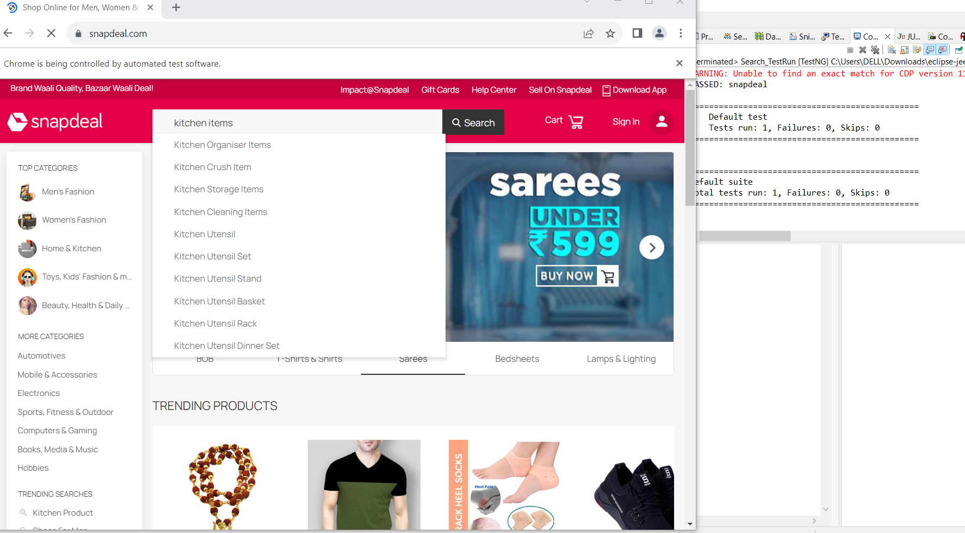

**SELECTION OF 10TH ITEM:**

**LOCATORS:**

**package** pom.without.pagefactory;

**import** org.openqa.selenium.By;

**public** **class** Select_item {

**public** **static** By *SelectItem* = By.*xpath*("(//p[@class='product-title'])[10]");

}

**EXCECUTION:**

package pom.without.pagefactory;

import org.openqa.selenium.WebElement;

import com.test.Baseclass;

public class Select_page extends Baseclass{

public static Select_item selected = new Select_item();

public static void kitchenItem() {

WebElement ele = findElement(selected.SelectItem);

ele.click();

}

}

**TEST RUN:**

**package** pom.without.pagefactory;

**import** org.testng.annotations.Test;

**public** **class** Select_TestRun {

@Test

**public** **static** **void** select() {

Search_page.*SearchMethod*();

Select_page.*kitchenItem*();

}

}

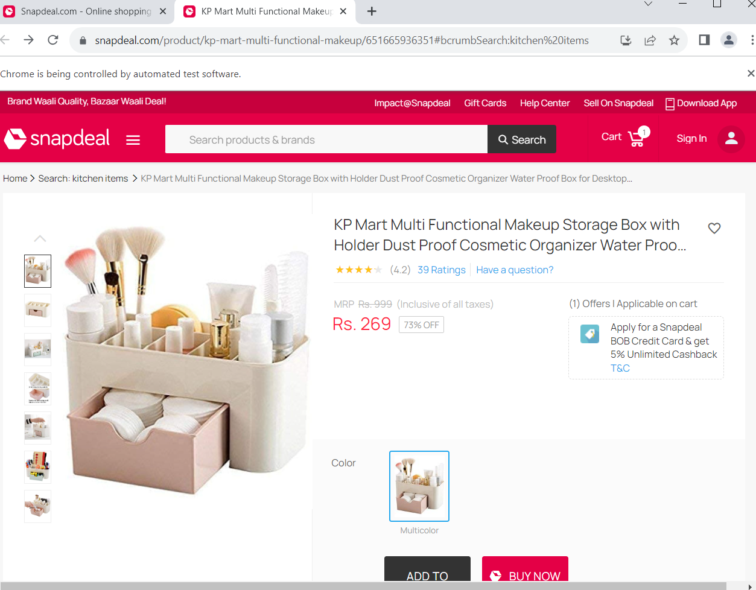

**ADD TO CART :**

**LOCATORS:**

**package** pom.without.pagefactory;

**import** org.openqa.selenium.By;

**public** **class** AddToCart_item {

**public** **static** By *addtocard* = By.*xpath*("//span[text()='add to cart']");

**public** **static** By *viewitem* = By.*xpath*("//div[text()='View Cart']");

}

**EXCECUTION:**

package pom.without.pagefactory;

import java.util.Set;

import org.openqa.selenium.WebElement;

import com.test.Baseclass;

public class AddToCart_page extends Baseclass {

public static AddToCart_item add1 = new AddToCart_item();

public static void switchwindows() throws InterruptedException {

String parent = driver.getWindowHandle();

// System.out.println(parent);

Set<String> child = driver.getWindowHandles();

// System.out.println(child);

for (String s : child) {

if (!parent.equals(s)) ;

Thread.sleep(2000);

driver.switchTo().window(s)

}

}

public static void cart() throws InterruptedException {

WebElement ele = findElement(add1.addtocard);

ele.click();

}

// public static AddToCart_item add2= new AddToCart_item();

public static void view() throws InterruptedException {

WebElement ele1 = findElement(add1.viewitem);

ele1.click();

}

}

**TEST RUN:**

**package** pom.without.pagefactory;

**import** org.testng.annotations.Test;

**public** **class** AddToCart_TestRun {

@Test

**public** **static** **void** AddCart() **throws** InterruptedException {

Search_page.*SearchMethod*();

Select_page.*kitchenItem*();

AddToCart_page.*switchwindows*();

AddToCart_page.*cart*();

AddToCart_page.*view*();

}

}

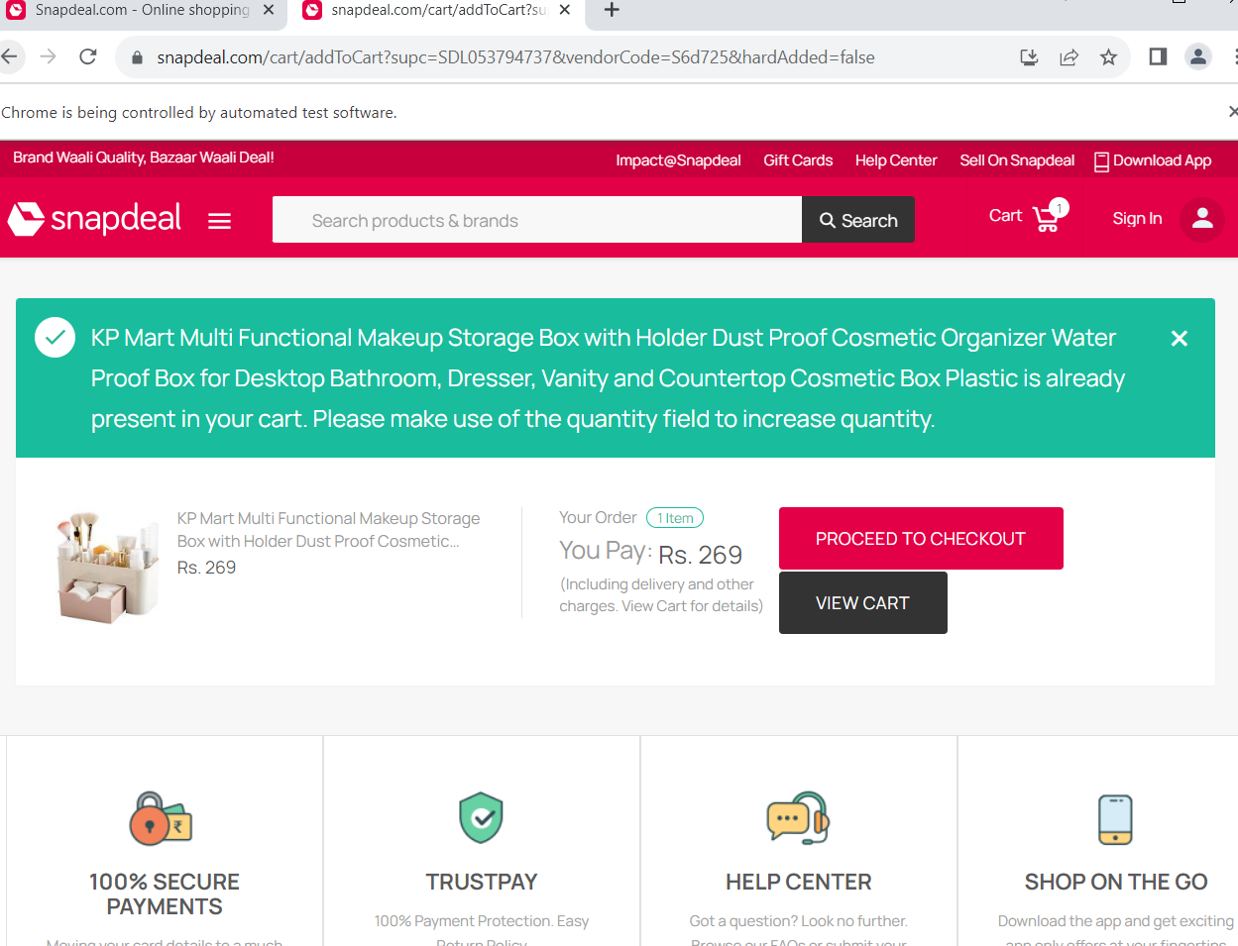

**CONSOLE:**

[RemoteTestNG] detected TestNG version 6.14.3

[TestNGContentHandler] [WARN] It is strongly recommended to add "<!DOCTYPE suite SYSTEM "http://testng.org/testng-1.0.dtd" >" at the top of your file, otherwise TestNG may fail or not work as expected.

SLF4J: No SLF4J providers were found.

SLF4J: Defaulting to no-operation (NOP) logger implementation

SLF4J: See https://www.slf4j.org/codes.html#noProviders for further details.

Aug 26, 2023 11:12:08 PM org.openqa.selenium.devtools.CdpVersionFinder findNearestMatch

WARNING: Unable to find an exact match for CDP version 116, so returning the closest version found: 115

PASSED: AddCart

===============================================

Default test

Tests run: 1, Failures: 0, Skips: 0

===============================================

===============================================

Default suite

Total tests run: 1, Failures: 0, Skips: 0

===============================================

FINAL PAGE(Validate the product added into the Cart):

